Global OHI fisheries model adjusted for SB/SBmsy

The fisheries goal takes into account the sustainability of the fishery through ratio between single species current spawner biomass at sea (SB) and the reference spawner biomass at maximum sustainable yield (SBMSY). This ratio was chosen as this ratio is used as reference points and targets in the Western and Central Pacific Fisheries stock assessments. The status score for each stock is penalized according to the SB model. Scores are reduced for stocks who are below or above target biomass levels.







Global Model Fisheries Score = 53.8

New Caledonia OHI+ Fisheries

The pelagic fisheries of New Caledonia sustain a constant annual catch to maintain a consistent market price. To account for this the species specific annual catches are weighted against the mean annual catch for that species. The fisheries goal takes into account the sustainability of the fishery through ratio between single species current spawner biomass at sea (SB) and the reference spawner biomass at maximum sustainable yield (SBMSY). This ratio was chosen as this ratio is used as reference points and targets in the Western and Central Pacific Fisheries stock assessments. This model does not penalize fisheries that are above their stock biomass targets. Therefore there is no penalty for under fishing the stock.







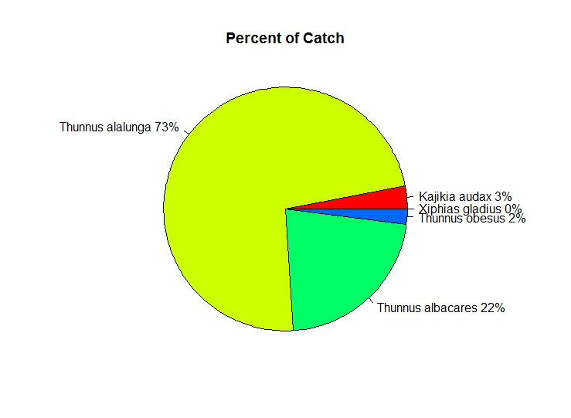

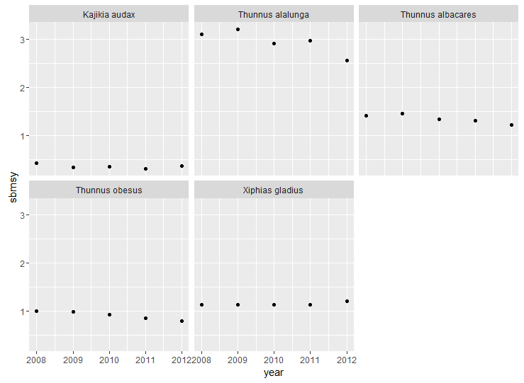

CN Fisheries Score = 97.9

Other possible models use weights of current catch to mean catch.



=



**New Caledonia Lasting Special Places Model**

$$x_{LSP}=\sum_{k=1}^{n}{\frac{A}{A_{ref}}}\frac{P}{P_{ref}}\frac{M}{M_{ref}}$$

*k =protected areas*

*n = total number of protected areas*

*A = area in Km2*

*Aref = reference area in km2 = 1,289,932.90 km2 (cumulative protected area in year 2016)*

*P = protection level based on IUCN categories*

*IUCN category scores = Cat Ia = 1*

*Cat II = 0.8*

*Cat III = 0.6*

*Cat IV = 0.4*

*Cat V = 0.2*

*Cat VI = 0.1*

*Pref = reference protection level*

*M = management level*

*Management category scores = Management Plan Implemented = 1*

*Management Plan Created & Not Implemented = 0.5*

*Management Plan in Development = 0.25*

*No plan = 0.1*

*Mref = reference management level*

**Results for status**

|  |  |  |  |  |  |  |  |  |  |
| --- | --- | --- | --- | --- | --- | --- | --- | --- | --- |
| rgn_id | Year | | cum_rel_prot | ref_point_1 | **status_1** | ref_point_2 | **status_2** | ref_point_3 | **status_3** |
| 1 | | 2008 | 0.06264 | 1289932.9 | **0** | 257986.58 | **0** | 128993.29 | **0** |
| 1 | | 2009 | 0.06264 | 1289932.9 | **0** | 257986.58 | **0** | 128993.29 | **0** |
| 1 | | 2010 | 0.06264 | 1289932.9 | **0** | 257986.58 | **0** | 128993.29 | **0** |
| 1 | | 2011 | 0.06264 | 1289932.9 | **0** | 257986.58 | **0** | 128993.29 | **0** |
| 1 | | 2012 | 0.06264 | 1289932.9 | **0** | 257986.58 | **0** | 128993.29 | **0** |
| 1 | | 2013 | 213.48204 | 1289932.9 | **0.02** | 257986.58 | **0.08** | 128993.29 | **0.17** |
| 1 | | 2014 | 32435.10454 | 1289932.9 | **2.51** | 257986.58 | **12.57** | 128993.29 | **25.14** |
| 1 | | 2015 | 32435.10454 | 1289932.9 | **2.51** | 257986.58 | **12.57** | 128993.29 | **25.14** |
| 1 | | 2016 | 32435.10454 | 1289932.9 | **2.51** | 257986.58 | **12.57** | 128993.29 | **25.14** |

Ran three different models using different reference points (**status scores in bold**):

* v1: reference point is total EEZ (total cumulative protection in 2014 = 1289932.90) at IUCN category Ia (score = 1) and Management Plan Implemented (score = 1)
* v2: reference point is total protected area (total cumulative protection in 2016 = 1289932.90) at IUCN category V (score = 0.2) and Management Plan Implemented (score = 1)
* v3: reference point is total protected area (total cumulative protection in 2016 = 1289932.90) at IUCN category V (score = 0.2) and Management Plan Created & Not Implemented (score 0.5)

All three models have a positive trend of +1 (the highest possible score).

Next steps:

* Confirm protection level category scores and management level category scores
* Determine reference point of choice (v1, v2, or v3)
* Identify pressures and resilience data (can default to global if necessary)